Liquid Rate Control Implementation
for Standard Well in GPRS

Krit Ngamkamollert

Introduction

In General Purpose Reservoir Simulator (GPRS), we have four kinds of well control methods, which are BHP control, gas rate control, oil rate control and water rate control. The liquid rate control uses the total liquid rate as the constraint to the wells, which is very common and frequently used in practice. The implementation of the liquid rate well control method into GPRS was done and can be found in “Implementation of New Well Controls in GPRS” by Yuanlin Jiang (see Attachment 1).

Once GPRS is updated to the current version (v 2.0), some modifications are needed to applied to the previous implementation in order to migrate to the current version. This is the main objective of this study and this report is based on the previous work as mentioned.

  - Formulation

The liquid rate well control method uses the total liquid rate (oil and water) as the constraint to wells. Based on the process of GPRS, this kind of rate control will introduce one well equation to the whole non-linear equation system. The conservation equation of the well is listed as follows:
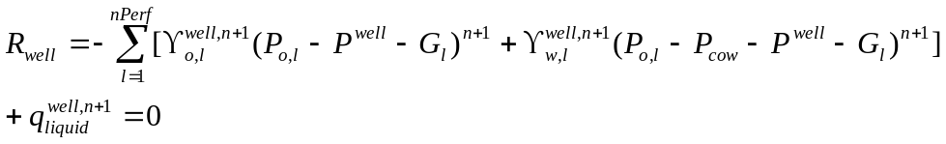 (1.1)
Here, is the label of the perforations, and 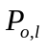 is the pressure of the block which contains the th of perforation. 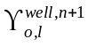 is the transmissibility of oil phase at the th of perforation. 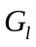 is the pressure difference between the reference point and the th of perforation, which is caused by hydraulic head, frictions, etc. And 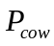 is the capillary pressure between oil and water phases.

If we ignore the capillary pressure, (1, 1) can be simplified as follows:
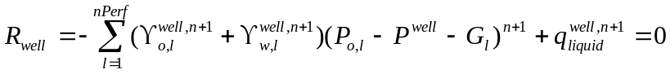 (1.2)
The corresponding Jacobi parts are following:
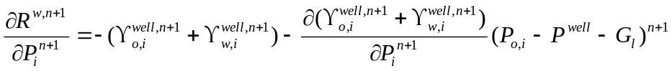 (1.3)
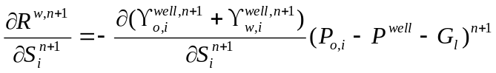 (1.4)
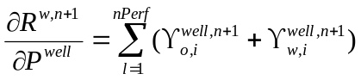 (1.5)
With these formulas, we are ready to implement the liquid control method. In this implementation of liquid rate control method, capillary pressure was also considered.

1.2 Implementation
In implementing the liquid control method, a new class “WellLRateCont” is added to GPRS, which is a subclass of class “WellCont”. (Fig. 1)
Well Ctrl
WRate
ORate
GRate
LRate
BHP

Figure 1: Relationship of well control methods

A new keyword “LRATE” is added to input files. See following example:
# --- well control (producer)----------------
# WCONPROD
# CTRL_TYPE QL minBHP std_den_o std_den_w
LRATE 20000 1000.0 49.1 64.79

New well control is very similar to original well control methods. Simply add above lines into the well control part of input files, the liquid control method will be activated. This implementation is compatible with the current version of GPRS. Original input files can work well without any further modification.

1.3 Test Cases
To validate the implementation, two cases were run using the liquid rate control. Then, the results were compared with Eclipse results.

1.3.1) Black Oil, Oil-Water case
In this case, two vertical wells exist in a 3D oil-water system, with 10 by 10 by 3 grids. The injector is located at a corner, and has 3 perforations. The water rate control method is used in the injector. The producer is drilled at the opposite corner, and also has 3 perforations. We now use liquid rate constraint on the producer. (Fig. 2)

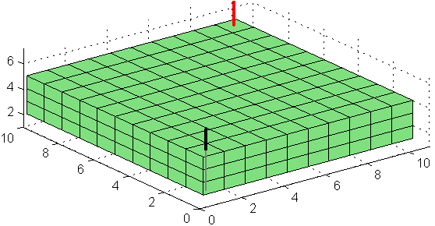
Figure 2: Model of the Oil-Water test case

We run the case for 1000 days, and water breaks through at about 380 days. The comparison of results between GPRS and Eclipse is as follows.
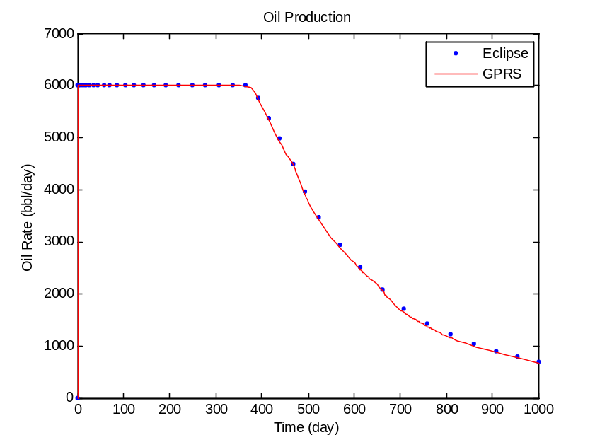
Figure 3: Oil production rate of GPRS and Eclipse

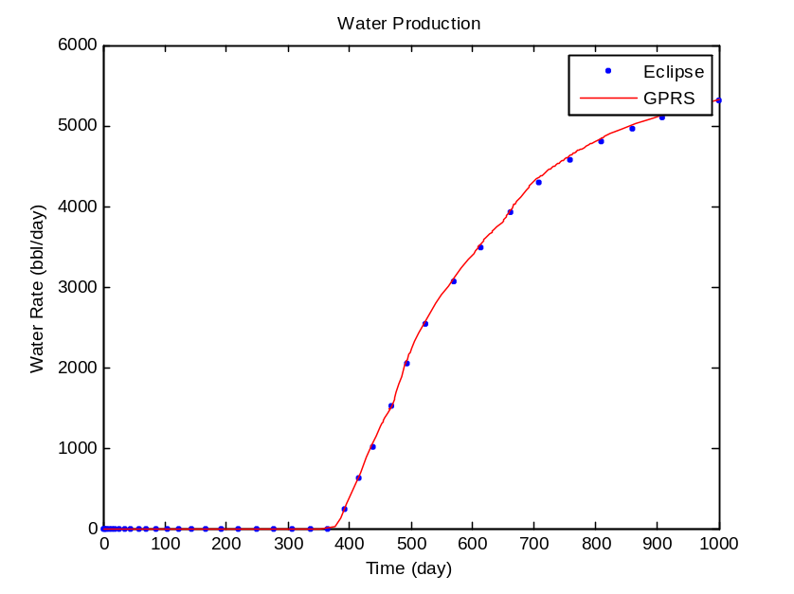
Figure 4: Water production rate of GPRS and Eclipse
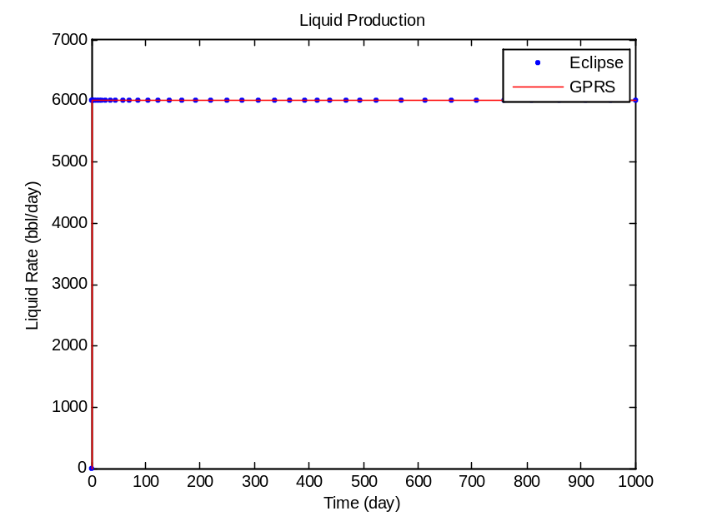
Figure 5: Liquid production rate of GPRS and Eclipse
From Figure 3 – 5, it is observed that we have a very good match between the results of GPRS and those of Eclipse. This verifies the implementation. More testing might be performed in future if needed.

1.3.2) Black Oil, 3 phases case (Oil-Water-Gas)
In this case, two vertical wells exist in a 3D oil-water-gas system, with 10 by 10 by 3 grids. The injector is located at a corner, and has 3 perforations. The gas rate control method is used in the injector. The producer is drilled at the opposite corner, and also has 3 perforations. We now use liquid rate constraint on the producer (Figure 6).
Figure 6: Model of the Oil-Water-Gas test case
We run the case for 1000 days. The comparison of results between GPRS and Eclipse is as follows.

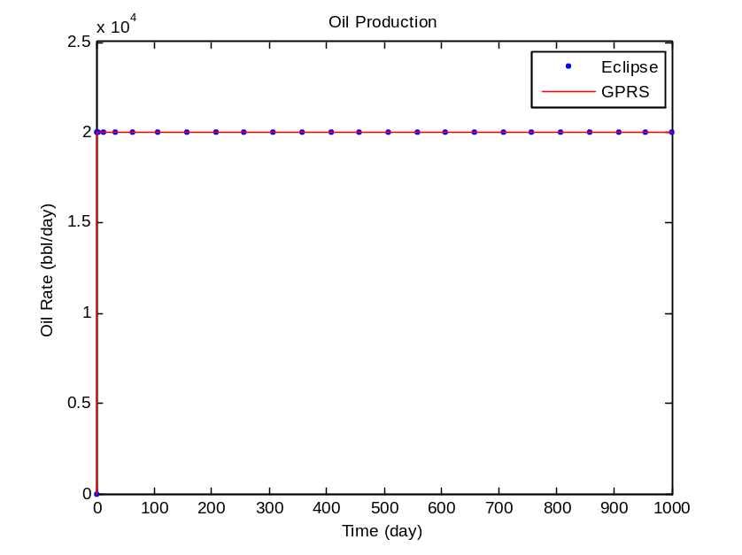
Figure 7: Oil production rate of GPRS and Eclipse
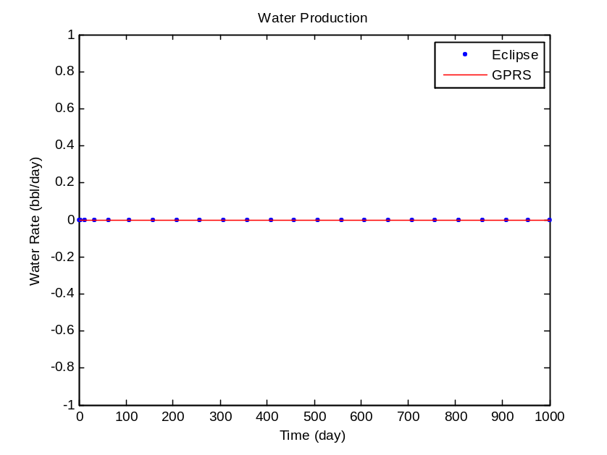
Figure 8: Water production rate of GPRS and Eclipse

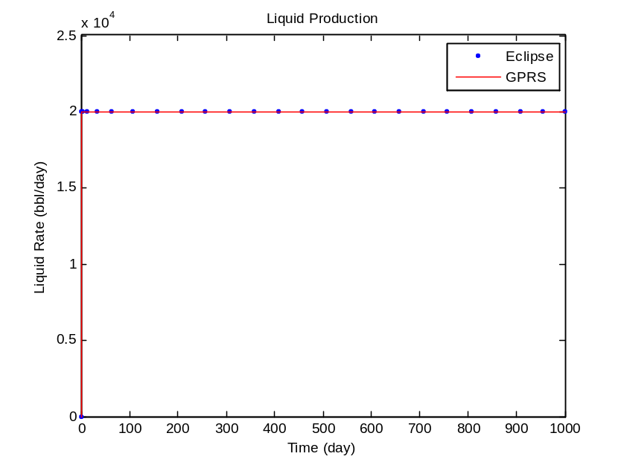
Figure 9: Liquid production rate of GPRS and Eclipse

From Figure 7 – 9, it is observed that we have a very good match between the results of GPRS and those of Eclipse. This verifies the implementation. More testing might be performed in future if needed.

